RANCANG BANGUN APLIKASI LEAN & IE
MANAGEMENT SYSTEM (LIMS)

SEBAGAI SISTEM INFORMASI UNTUK MENINGKATKAN
PRODUKTIVITAS, DAN PENGENDALIAN
PROSES OPERASIONAL



Oleh:
Fauzan Fadhillah Arisandi
NIK: N260102104

DEPARTEMEN LEAN & INDUSTRIAL ENGINEERING
PT.QUTY KARUNIA
PURWAKARTA
2026

- Tech Stack & Hardware Specifications
Tech Stack
Component | Tools |  | Used for
Backend | Laravel 10 |  | Authentication, API , excel generation , logic
Frontend | Next.js |  | Fast User interface
Styling | Tailwind CSS |  | Rapid Responsive Design
Server State | React Query |  | Caching , background refetching  Loading states
Client State | Zustand |  | Simple global state (user , filters , theme)
Database | Mysql |  | Data Store
Excel | PhpSpreadsheet / Laravel excel  (nanti ditentukan) |  | Generate reports
Hardware Specifications
RAM |  | 16 GB – 32 GB |  | Multitasking
Storage / SSD |  | 500 GB |  | Database Storage
Tabel 1.1 Tech Stack & Hardware Specifications

Tabel Database

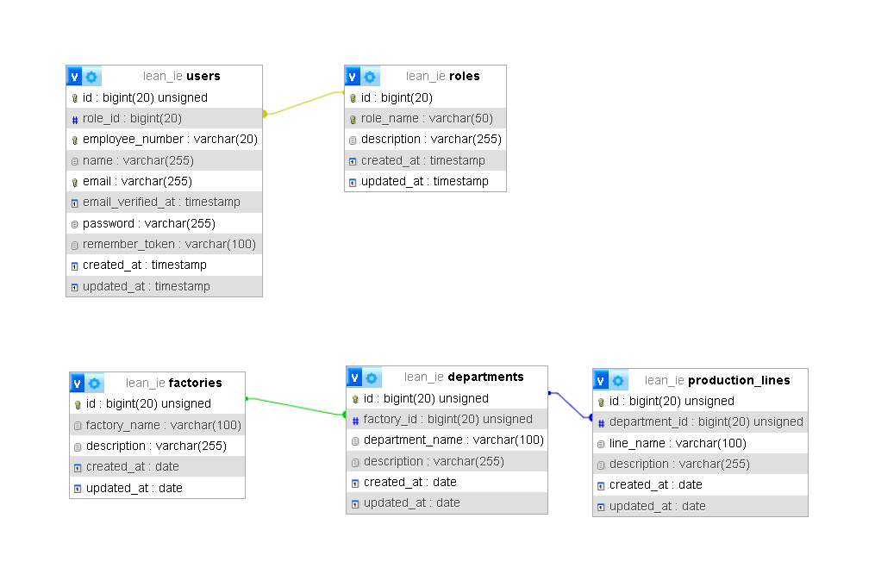
Gambar 2.1 Tabel Database

